Request for Proposals Questions and Answers
Private Infrastructure Investment Management Services

1. Based on the RFI’s emphasis on value-added infrastructure, would an expected target net return in the low-double-digit range approximately 10–12% be considered/desired or a 13-15% expected target net return be more in line for the client's return expectations?

The RFP purposefully does not specify an expected return to allow consideration of various approaches. That being said, on the spectrum of yield vs. growth, our bias is toward growth and total return. Additional perspective is provided by Albourne Board education in October 2025.
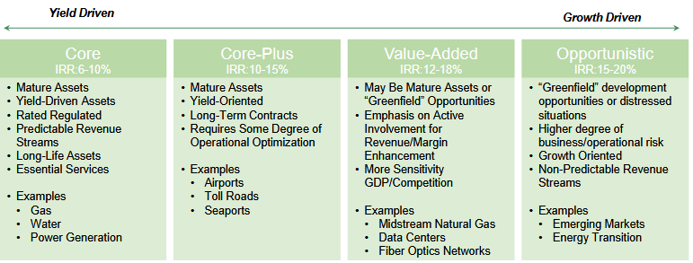
https://www.ipopif.org/Resources/66c70adb-2b3a-4564-890c-64745f4f5741/10-17-2025/

- In reviewing the materials related to the recently released Private Infrastructure RFP, we wanted to confirm whether the scope of this infrastructure search includes infrastructure debt in addition to infrastructure equity. If infrastructure debt is within scope, could you please clarify the level or range of debt exposure IPOPIF would consider appropriate within the overall mandate?

The RFP scope of services does not specifically reference equity or debt. Proposals that include debt will be considered if they meet the scope of services as defined in the RFP. We expect that substantial equity exposure will be necessary to achieve the desired Value-Added profile.

- Our Infrastructure platform is primarily focused on secondaries with broad capabilities across primaries and co-investments as well. We have deep experience managing SMAs similar to this search.

Our focus is to partner with high quality infrastructure GPs on a global basis across primaries, secondaries, and co-investments. Given this, would platforms like ours be considered given the RFP states that initial implementation is expected to focus on direct investments.

Yes, the platform as described above would be considered if it meets the scope of services as defined in the RFP. We note that the RFP Scope of Services includes a preference for “Flexibility to incorporate secondaries, primary fund investments, and co-investments.”

- We had a quick question regarding the RFI submission — should we be providing a redacted version at this stage in the search process? We understand submissions are subject to FOIA, so we wanted to confirm expectations before finalizing and submitting our response.

Following is guidance regarding confidential information that applies to all submissions, including the RFI.

All documents created as part of an RFP, including a Candidate’s responses, shall be considered public records and shall be made available for inspection and copying as provided in Section 3 of the Illinois Freedom of Information Act, 5 ILCS 140/1, et seq. (“FOIA”). Section 7(1)(h) of FOIA exempts from production proposals, bids, and information which, if disclosed, would frustrate procurement, until an award or final selection is made. Pursuant to Section 7(1)(h), IPOPIF does not intend to make public any Candidate responses until an award or final selection is made. Further, Section 7(1)(g) exempts from production “trade secrets and commercial or financial information obtained where the trade secrets or commercial or financial information are furnished under a claim that they are proprietary, privileged, or confidential, and that disclosure of the trade secrets or commercial or financial information would cause competitive harm to the person or business, and only insofar as the claim directly applies to the records requested.” To the extent that a Candidate represents to the IPOPIF in its RFP response that the Section 7(1)(g) exemption applies, the Candidate must mark each page accordingly and provide a separate version of the response that redacts only those pages, or portions of pages, that include such information.

